These 2 phone calls would be concerning Tony calling and asking me to send him an email that I could/would deploy. In one of the calls, I advised Tony that I had just reached out for leadership assistance and the RAR had been put in an expedited ques and we should just wait until it goes through the process, which had, at that time, been open for 190 days with no comms.

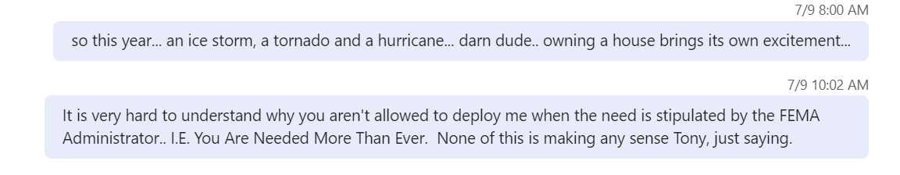

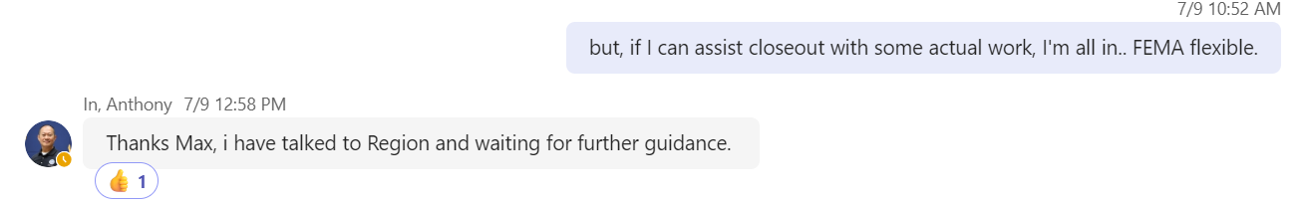

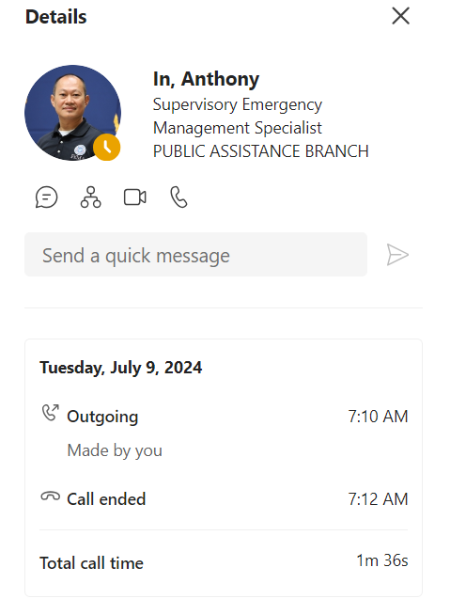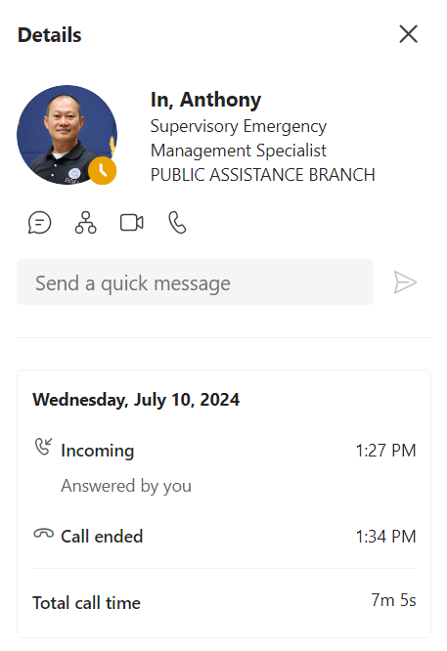

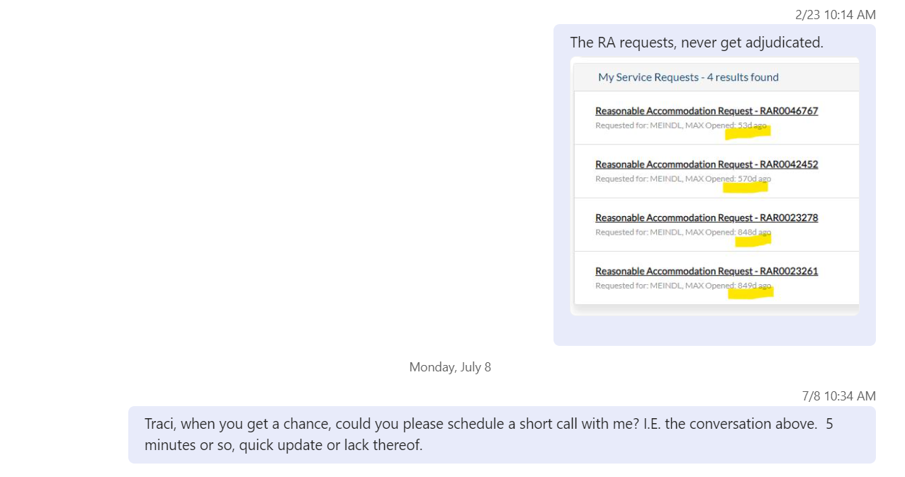

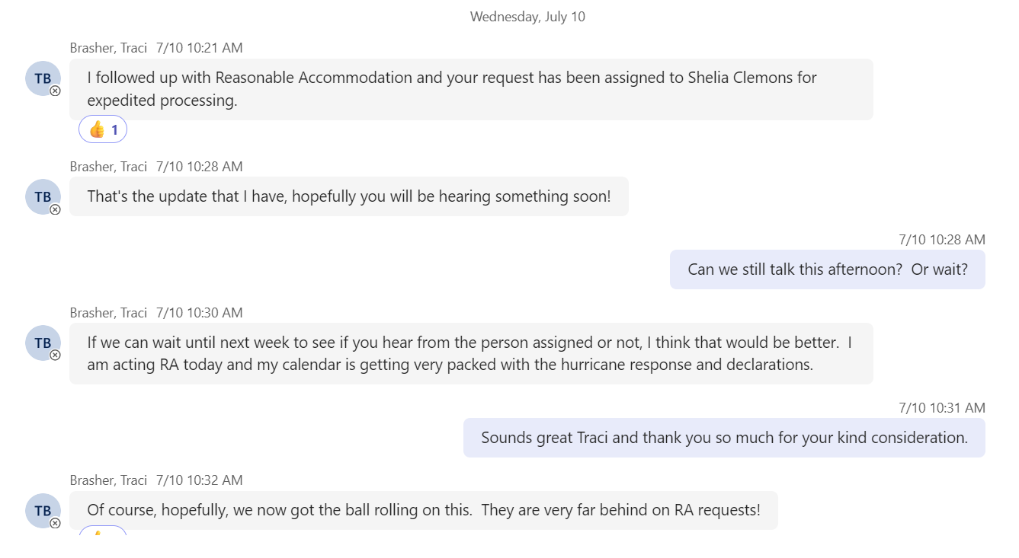

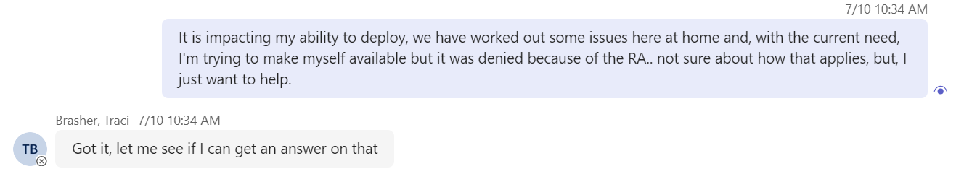

The reason I reached out to leadership is because in the conversation with Tony, on 7/09/24, I did express my concern(s) about his asking me if I could deploy to Houston (on 5/23/24- Teams, see snip below), to Houston, to which I agreed. Tony called me a few minutes later to say he had been overruled (phone snip below, 9 minutes between the conversation where I accepted the proposed accommodation (12:59 PM), in my mind at least, and when Tony called (1:08 PM) me back to say he had been overruled.

I stated that it felt like targeted retaliation; not letting me deploy, throttling my assigned workload way below my capabilities. I expressed my displeasure and Tony told me he had been told to “stand down” on this issue. That’s my SOR being told to stand down as we were working together to accommodate.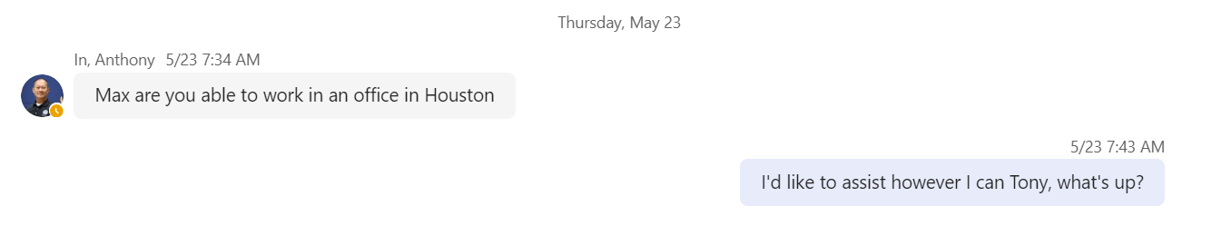

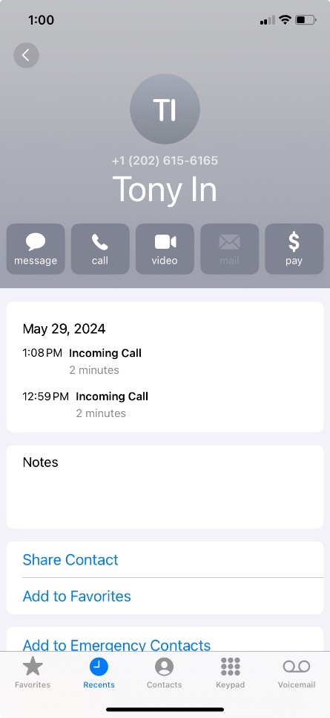

All comms with Jodi Hunter, interactive conversation.

